Image resolution, aspect ratio and pixel ratio of the rendered image.

Visual Effects & Alpha channels

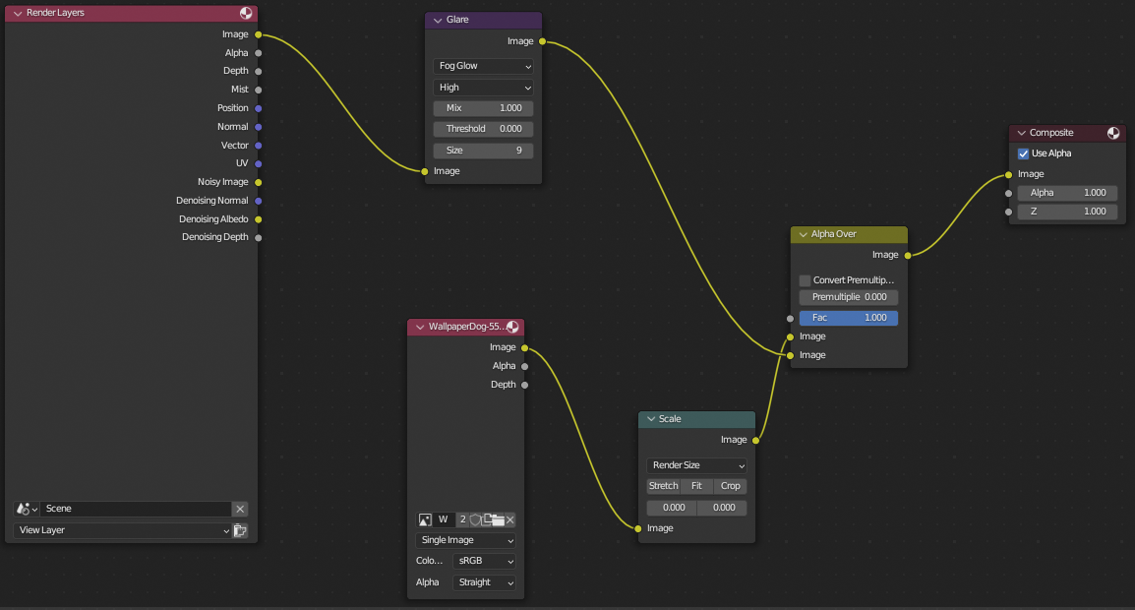

This adds a glare effect to the render.

This is the alpha channel.

It adds an image to be the background when there is blank space.

All images and textures are linked and working.

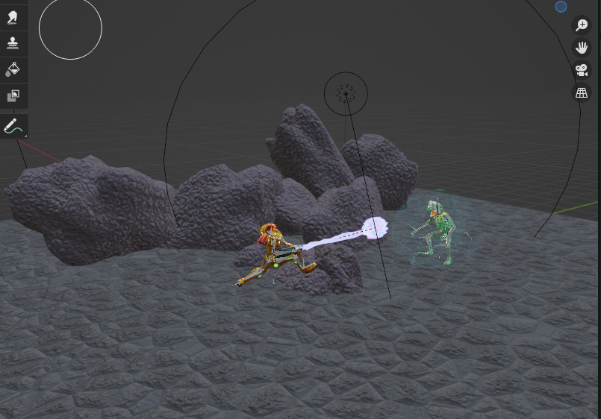

There is no missing texture pink which means all the textures work.

Opacity matts.

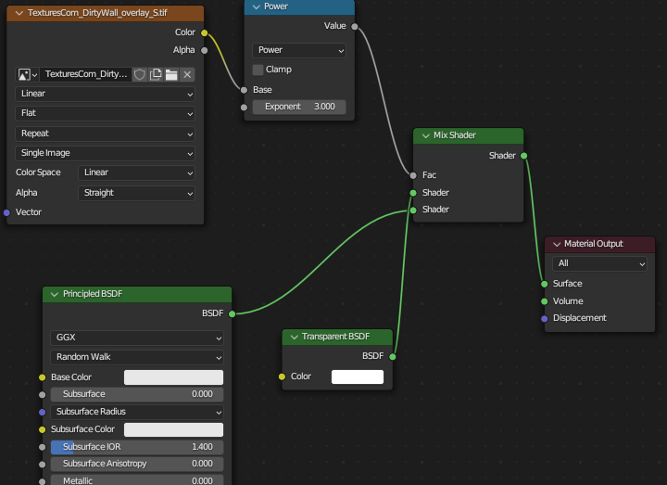

Render layers and passes.

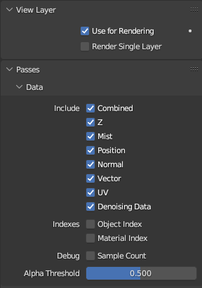

Documentation for each of these